Donasco, Jomer John L. 2301314

1CPE-A

class Activity:

    def helloWorld(self):

        print("You selected Hello World Program \n")

        message = "Hello World"

        print(message + "\n")

run1 = Activity()

run1.helloWorld()

run2 = Activity()

run2.helloWorld()

Output:

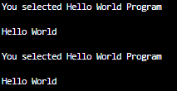

class Activity:

    def arithmetic(self):

        print("You selected Arithmetic Program \n")

        intInput1 = float(input("Please input first number: "))

        intInput2 = float(input("Please input second number: "))

        sumInt = intInput1 + intInput2

        diff = intInput1 - intInput2

        prod = intInput1 * intInput2

        quo = intInput1 / intInput2

        print(f"The sum is {sumInt}")

        print(f"The difference is {diff}")

        print(f"The product is {prod}")

        print(f"The quotient is {quo}")

        print("")

run1 = Activity()

run1.arithmetic()

run2 = Activity()

run2.arithmetic()

Output

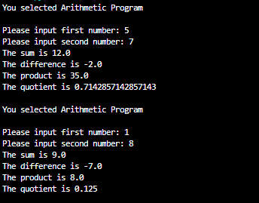

class Activity:

    def positiveCheck(self):

        print("You selected Positive or Negative Program \n")

        userInput = float(input("Please input a number: "))

        if userInput >= 0:

            print(f"{userInput} is a positive number")

        elif userInput < 0:

            print(f"{userInput} is a negative number")

        else:

            print("error")

        print("")

run1 = Activity()

run1.positiveCheck()

run2 = Activity()

run2.positiveCheck()

Output

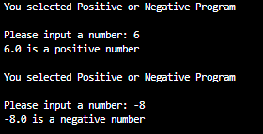

class Activity:

    def feetToInch(self):

        print("You selected Feet to Inch Conversion \n")

        userInput = float(input("Please input a measurement in ft: "))

        conversion = userInput * 12

        print(f"{userInput}ft is equivalent to {conversion} \n")

run1 = Activity()

run1.feetToInch()

run2 = Activity()

run2.feetToInch()

Output

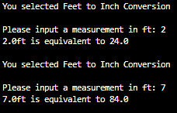

import math

class Activity:

    def circumference(self):

        userInput = float(input("Please input the radius: "))

        circumference = 2 * math.pi * userInput

        print(f"The circumference is {circumference:.2f}\n")

run1 = Activity()

run1.circumference()

run2 = Activity()

run2.circumference()

Output

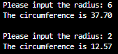

class Activity:

    def fibonnacci(self):

        print("You selected Fibonacci Sequence Program \n")

        terms = int(input("Please input the number of terms: "))

        first = 0

        second = 1

        print(first, second, end=" ")

        for count in range(2, terms):

            c = first + second

            print(c, end=" ")

            first = second

            second = c

        print("")

run1 = Activity()

run1.fibonnacci()

run2 = Activity()

run2.fibonnacci()

Output

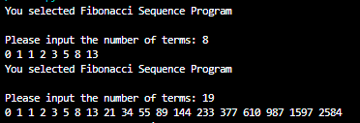

import string

import random

class Activity:

    def passwGen(self):

        print("You selected Password Generation Program \n")

        passLenInput = int(input("Please input the length of your password: "))

        char = string.ascii_letters + string.digits + string.punctuation

        randString = ''.join(random.choices(char, k=passLenInput))

        print(randString)

        print("")

run1 = Activity()

run1.passwGen()

run2 = Activity()

run2.passwGen()

Output

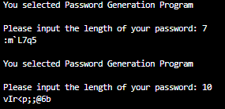

class Activity:

    def reverse(self):

        print("You selected Reverse String Program \n")

        string = input("Please input anything: ")

        print(string[::-1])

        print("")

run1 = Activity()

run1.reverse()

run2 = Activity()

run2.reverse()

Output

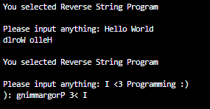

class Activity:

    def calculator(self):

        print("You selected Calculator Program \n")

        intInput1 = float(input("Please enter first number: "))

        intInput2 = float(input("Please enter second number: "))

        operator = input("Select an operator (+, -, *, /): ")

        if operator == "+":

            sumInt = intInput1 + intInput2

            print(sumInt)

        elif operator == "-":

            diff = intInput1 - intInput2

            print(diff)

        elif operator == "*":

            prod = intInput1 * intInput2

            print(prod)

        elif operator == "/":

            quo = intInput1 / intInput2

            print(quo)

        else:

            print("error")

        print("")

run1 = Activity()

run1.calculator()

run2 = Activity()

run2.calculator()

Output

